Course Name: | Elements of Electrical and Electronics Engineering | Semester: | I
Date of Performance: | / / 2022 | Batch No: | C3-3
Faculty Name: | Annu Abraham | Roll No: | 16010122221
Faculty Sign & Date: |  | Grade/Marks: | / 25

Experiment No: 1
Title: Study of Various types of Electronic and Electrical components and Instruments.

Aim and Objective of the Experiment:
- To understand the working principle of various components and Instruments.
- To understand the applications of various components and Instruments.
Bread Board, Resistors, Capacitors, Inductors, Diodes, BJT, Switches, Cathode Ray
Oscilloscope, Function Generator.

COs to be achieved:
CO1: Analyze resistive networks excited by DC sources using various network theorems.
.

Theory:
A breadboard is a rectangular plastic board with a bunch of tiny holes in it. These holes let you easily insert electronic components to assemble an electronic circuit, like this one with a battery, switch, resistor, and an LED (light-emitting diode). The connections are not permanent, so it is easy to remove a component if you make a mistake, or just start over and do a new project. Remember that the inside of the breadboard is made up of sets of five metal clips. This means that each set of five holes forming a half-row (columns A–E or columns F–J) is electrically connected. For example, that means hole A1 is electrically connected to holes B1, C1, D1, and E1. It is not connected to hole A2, because that hole is in a different row, with a separate set of metal clips. It is also not connected to holes F1, G1, H1, I1, or J1.

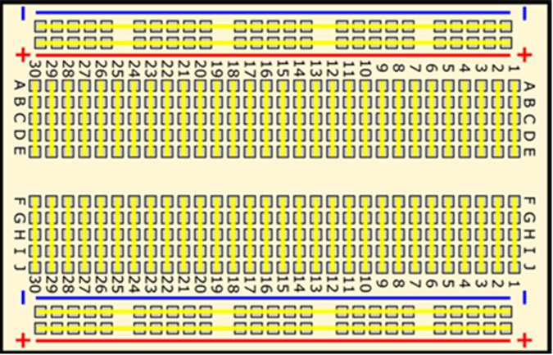
Fig. Bread board

Resistors: Those components and devices, which are specially designed to have a certain amount of resistance and used to oppose or limit the electric current, is called resistors. Each resistor has two main characteristics.
- Its resistance value in ohms and 2) its power dissipating capacity in watts
Resistors are employed for many purposes such as electric heaters, telephone equipment’s, electric and electronic circuit elements and in current limiting devices. As resistors are used in wide applications, there values like power rating, R-value, tolerance vary. Resistors of resistance value ranging from .1ohms to many mega ohms are manufactured. Acceptable tolerance levels range from +/- 20% to as low as +/-.001%. The power rating may be as low as 1/10 watts and can be in several hundred watts. These all vary in range and type of application a particular resistor is used. Classification of Resistors: From operating conditions point of view, resistors can be classified into two

- Fixed resistors
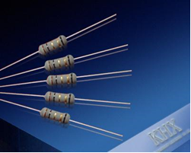
- Variable Resistor (POT):

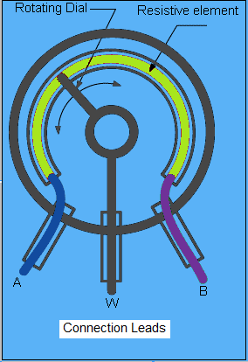

1) Fixed resistors are further classified into:
a) Carbon composition type resistors
b) Metalized type resistors
c) Wire wound type resistors
a) Carbon composition type resistors: This is the most common type of low wattage resistor. The resistive material is of carbon-clay composition and the leads are made of tinned copper. These resistors are cheap and reliable and stability is high.
b) Wire wound resistors: These resistors are a length of wire wound an insulating cylindrical core. Usually wires of material such as constantan (60% copper and 40% nickel) and manganin which have high resistivities and low temperature coefficients are employed. The completed wire wound resistor is coated with an insulating material such as baked enamel.
c) Metalized resistors: It is constructed using film deposition techniques of depositing a thick film of resistive material onto an insulating substrate.
2) Variable resistors:
For circuits requiring a resistance that can be adjusted while it remains connected in the circuit (for eg: volume control on radio), variable resistors are required. They usually have 3 lead two fixed and one movable.
Resistor Color Code:

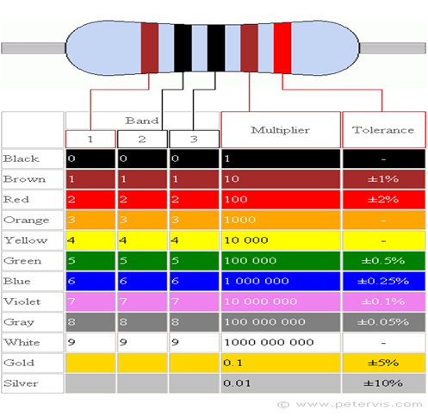

Capacitor:
Electronic capacitors are one of the most widely used forms of electronics components. However there are many different types of capacitor including electrolytic, ceramic, tantalum, plastic, sliver mica, and many more. Each capacitor type has its own advantages and disadvantages can be used in different applications.

Overview of different capacitor types
There are many different types of capacitor that can be used - most of the major types are outlined below:

Ceramic capacitor: The ceramic capacitor is a type of capacitor that is used in many applications from audio to RF. Values range from a few Pico farads to around 0.1 microfarads. Ceramic capacitor types are by far the most commonly used type of capacitor being cheap and reliable and their loss factor is particularly low although this is dependent on the exact dielectric in use.
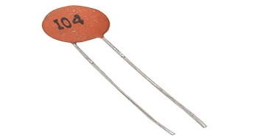
Electrolytic capacitor: Electrolytic capacitors are a type of capacitor that is polarized. They are able to offer high capacitance values - typically above 1μF, and are most widely used for low frequency applications - power supplies, decoupling and audio coupling applications as they have a frequency limit if around 100 kHz.
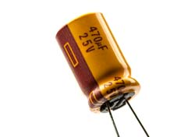
Tantalum capacitor: Like electrolytic capacitors, tantalum capacitors are also polarized and offer a very high capacitance level for their volume. However this type of capacitor is very intolerant of being reverse biased, often exploding when placed under stress. This type of capacitor must also not be subject to high ripple currents or voltages above their working voltage.
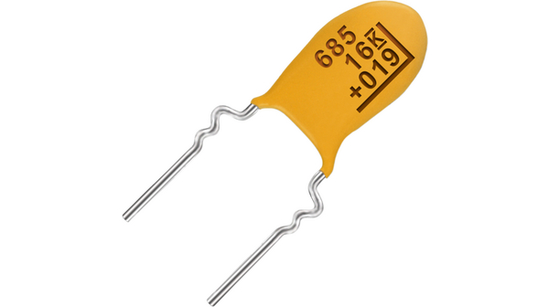
Polystyrene Film Capacitor: Polystyrene capacitors are a relatively cheap form of capacitor but offer a close tolerance capacitor where needed. They are tubular in shape resulting from the fact that the plate / dielectric sandwich is rolled together, but this adds inductance limiting their frequency response to a few hundred kHz. They are generally only available as leaded electronics components.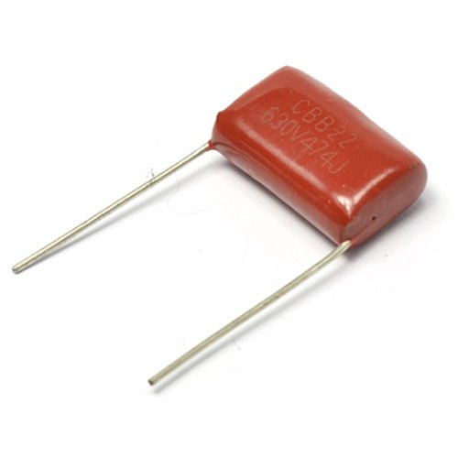
Metallized Polyester Film Capacitor: This type of capacitor is a essentially a form of polyester film capacitor where the polyester films themselves are metallized. The advantage of using this process is that because their electrodes are thin, the overall capacitor can be contained within a relatively small package. The metallized polyester film capacitors are generally only available as leaded electronics components.
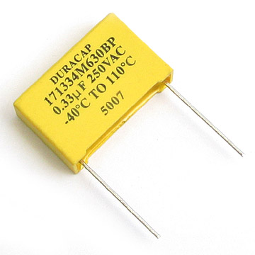
Inductors: Inductors have a wide variety and important applications in electronics. Inductors are available for high power applications, noise suppression, radio frequency, signals, and isolation.

Different inductor core types
Like other types of component such as the capacitor, there are very many different types of inductor. However it can be a little more difficult to exactly define the different types of inductor because the variety of inductor applications is so wide.
Although it is possible to define an inductor by its core material, this is not the only way in which they can be categorized. However for the basic definitions, this approach is used.
Air cored inductor: This type of inductor is normally used for RF applications where the level of inductance required is smaller. The fact that no core is used has several advantages: there is no loss within the core as air is lossless, and these results in a high level of Q, assuming the inductor or coil resistance is low. Against this the number of turns on the coil is larger to gain the same level of inductance and this may result in a physical increase in size.
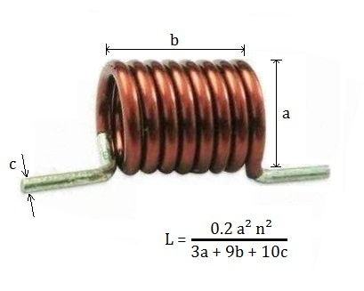
- Iron cored inductor: Iron cores are normally used for high power and high inductance types of inductor. Some audio coils or chokes may use iron laminate. They are generally not widely used.
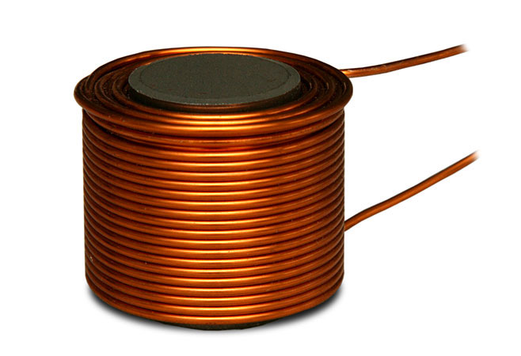
- Ferrite cored inductor: Ferrite is one of the most widely used cores for a variety of types of inductor. Ferrite is a metal oxide ceramic based around a mixture of Ferric Oxide Fe2O3 and either manganese-zinc or nickel-zinc oxides which are extruded or pressed into the required shape.
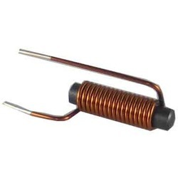
- Iron powder inductor: These are formed from very fine particles with insulated particles of highly pure iron powder. This type of inductor contains nearly 100% iron only. It gives us a solid looking core when this iron power is compressed under very high pressure and mixed with a binder such as epoxy or phenolic. By this action iron powder forms like a magnetic solid structure which consists of distributed air gap.
Due to this air gap it is capable to store high magnetic flux when compared with the ferrite core. This characteristic allows a higher DC current level to flow through the inductor before inductor saturates. This leads to reduce the permeability of the core.
Mostly the initial permeability’s are below 100 only. Thus these inductors posses with high temperature co-efficient stability. These are mainly applicable in switching power supplies.
Another core that can be used in a variety of types of inductor is iron oxide. Like ferrite, this provides a considerable increase in the permeability, thereby enabling much higher inductance coils or inductors to be manufactured in a small space.
Diodes:
A diode is an electric device that permits the flow of current only in one direction and restricts the flow in the opposite direction. The most ordinary sort of diode in current circuit design is the semi-conductor diode, even though additional diode technologies are present. The word “diode” is traditionally aloof for tiny signal appliances, I ≤ 1 A. When a diode is positioned in a simple battery lamp circuit, then the diode will either permit or stop flow of current through the lamp, all this depend on the polarization of the volts applied. There are various sorts of diode but their fundamental role is identical. The most ordinary kind of diode is silicon diode.
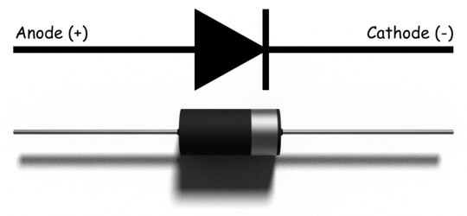
Transistor:
Bi-polar transistors are amongst the most widely used devices for amplification of all types of electrical signals in discrete circuits, i.e. circuits made from individual components rather than integrated circuits (I/Cs). BJTs are also used in circuits together with I/Cs, since it is often more practical to use discrete output transistors where a higher power output is needed than the I/C can provide.
- BUH515: High Voltage (1500V) high power (50W) NPN fast switching transistor in an ISO WATT 218 package originally designed for use in analogue TV time bases but also used in switched mode power supplies.
- 2N3055: NPN Silicon Power transistor (115W) designed for switching and amplifier applications. Can be used as one half of a complementary push-pull output pair with the PNP MJ2955 transistor.
- 2N2219 : NPN silicon transistor in a metal cased TO-39 package, designed for use as a high speed switch or for amplification at frequencies from DC (0Hz) up to UHF at about 500MHz.
- 2N6487: General purpose NPN output transistor with a power rating up to 75W in a TO-220 package.
- BD135/BD136: Complementary (NPN/PNP) pair of low, medium power audio output transistors in a SOT-32 package.
- 6, 7 and 8. 2N222 :Small signal general purpose amplifier and switching transistors like the 2N2222 and 2N3904 are commonly available in a variety of package types such as the TO-18 metal cased package (6)

Switches: A switch is a device which is designed to interrupt the current flow in a circuit, in other words, it can make or break an electrical circuit. Every electrical and electronics application uses at least one switch to perform ON and OFF operation of the device.
Switches can be of mechanical or electronic type

Mechanical Switches
Mechanical switches can be classified into different types based on several factors such as method of actuation (manual, limit and process switches), number of contacts (single contact and multi contact switches), number of poles and throws (SPST, DPDT, SPDT, etc.), operation and construction (push button, toggle, rotary, joystick, etc), based on state (momentary and locked switches), etc.

Single Pole Single Throw Switch (SPST)
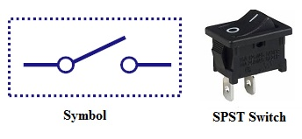
This is the basic ON and OFF switch consisting of one input contact and one output contact. It switches a single circuit and it can either make (ON) or break (OFF) the load. The contacts of SPST can be either normally open or normally closed configurations.
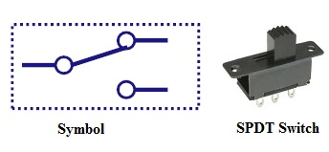
Single Pole Double Throw Switch (SPDT)
- This switch has three terminals, one is input contact and remaining two are output contacts.
- This means it consist two ON positions and one OFF position.
- In most of the circuits, these switches are used as changeover to connect the input between two choices of outputs.

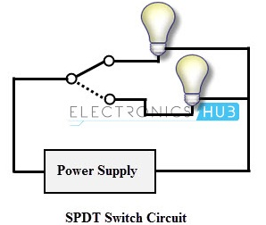
- The contact which is connected to the input by default is referred as normally closed contact and contact which will be connected during ON operation is a normally open contact.

Double Pole Single Throw Switch (DPST)
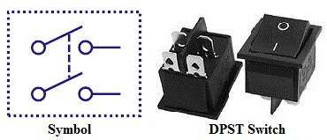
- This switch consists of four terminals, two input contacts and two output contacts.
- It behaves like a two separate SPST configurations, operating at the same time.
- It has only one ON position, but it can actuate the two contacts simultaneously, such that each input contact will be connected to its corresponding output contact.
- In OFF position both switches are at open state.
- This type of switches is used for controlling two different circuits at a time.
- Also, the contacts of this switch may be either normally open or normally closed configurations.

Double Pole Double Throw Switch (DPDT)

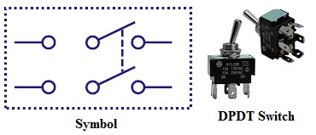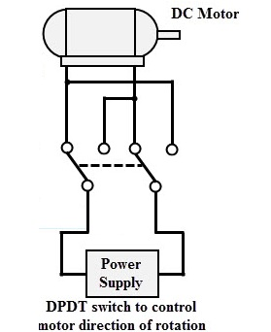
- This is a dual ON/OFF switch consisting of two ON positions.
- It has six terminals, two are input contacts and remaining four are the output contacts.
- It behaves like a two separate SPDT configuration, operating at the same time.
- Two input contacts are connected to the one set of output contacts in one position and in another position, input contacts are connected to the other set of output contact

Push Button Switch
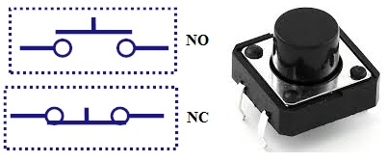
- It is a momentary contact switch that makes or breaks connection as long as pressure is applied (or when the button is pushed).
- Generally, this pressure is supplied by a button pressed by someone’s finger.
- This button returns its normal position, once the pressure is removed.
- The internal spring mechanism operates these two states (pressed and released) of a push button.
- It consists of stationary and movable contacts, of which stationary contacts are connected in series with the circuit to be switched while movable contacts are attached with a push button.
- Push buttons are majorly classified into normally open, normally closed and double acting push buttons as shown in the above figure.
- Double acting push buttons are generally used for controlling two electrical circuits.

Toggle Switch

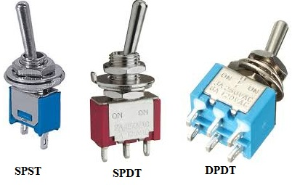
- A toggle switch is manually actuated (or pushed up or down) by a mechanical handle, lever or rocking mechanism. These are commonly used as light control switches.
- Most of these switches come with two or more lever positions which are in the versions of SPDT, SPST, DPST and DPDT switch. These are used for switching high currents (as high as 10 A) and can also be used for switching small currents.
- These are available in different ratings, sizes and styles and are used for different type of applications. The ON condition can be any of their level positions, however, by convention the downward is the closed or ON position
Cathode Ray Oscilloscope (CRO)

The cathode ray oscilloscope is an electronic test instrument; it is used to obtain waveforms when the different input signals are given. The oscilloscope observes the changes in the electrical signals over time, thus the voltage and time describe a shape and it is continuously graphed beside a scale. By seeing the waveform, we can analyze some properties like amplitude, frequency, rise time, distortion, time interval and etc. A built-in Component Tester makes it an indispensable instrument, as this allows testing of both passive and active components, while connected in-circuit. The one used in the lab is 30 MHz Oscilloscope with Color LCD Digital Readout & Component Tester.

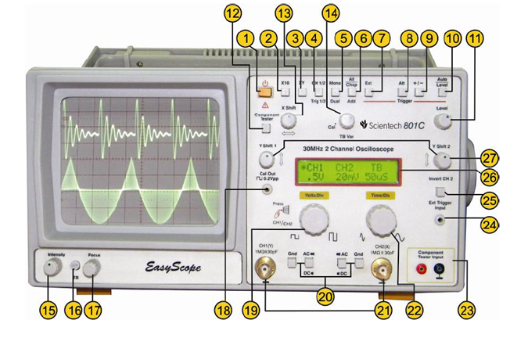

Some of the Panel controls are described below:

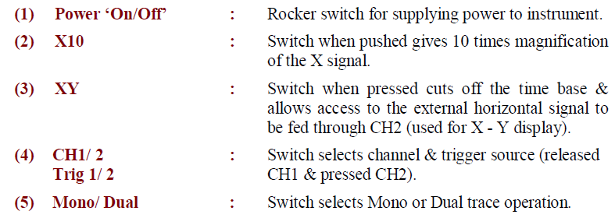

Method: Apply a know amplitude and frequency of sine/triangular/square wavefrom from signal generator and connect it to one of the channel’s of the CRO for measurment.

Observation Table:
Observation Table 1

Color code of Resistor/Capacitor | Theoritical Value | Practical Value (DMM)
 | 560 | 562
  Green - Blue – Brown
 | 1000  460  330 | 992  458  325
  Brown - Black - Red
  Yellow - Violet - Brown
  Orange - Orange - Brown

Observation Table 2

Waveform Nature | Theoritical | Measured frequency (Hz) | Theoritical | Measured amplitude peak to peak (V)
Sine wave | 102.2 | 108.6 | 2.0 | 1.8
Square wave | 101.9 | 100.0 | 2.0 | 2.0
Traingular wave | 104.3 | 108.6 | 2.0 | 1.9

Snap shot of CRO output:
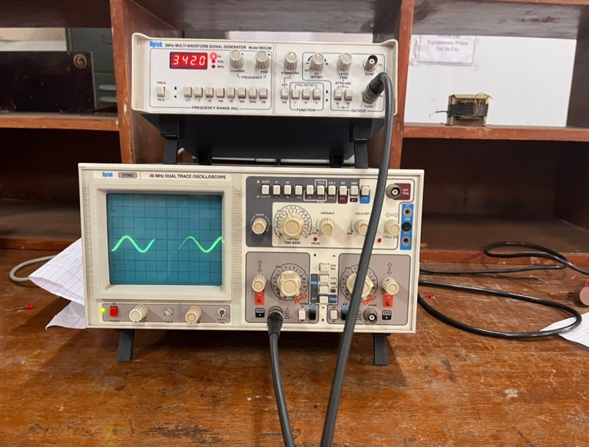
Calculation:

Measurement of Voltage

Waveform Nature | Number of Division (a) | Volts per division (b) | Peak to peak (a*b) | Display value
Any wave | 2 | 1 | 2 | 1.98

Measurement of Frequency

Waveform Nature | Number of Division (a) | time per division (b) | Frequency (1/(a*b*10-3)) (Hz) | Display value (Hz)
Any wave | 2.8 | 2 | 178.57 | 177.2

Function Generator:
Multi-Waveform Signal Generator can be used as a signal source to check amplifiers, filters, attenuators and also to generate in circuit based signals. The wide Frequency range from 0.01Hz up to 1MHz / 2MHz / 3MHz through coarse and fine controls makes quick adjustment possible. It has the following features: a) Wide Frequency Range b) Sine, Triangle, Square, Ramp, Pulse, TTL (Sync) & DC Outputs c) Low Distortion High Resolution on Low Frequency Output Attenuation upto 80dB d) Variable DC Offset Control and e) Four Digit Digital Display with Frequency Indication in Hz, KHz, MHz / Amplitude display.

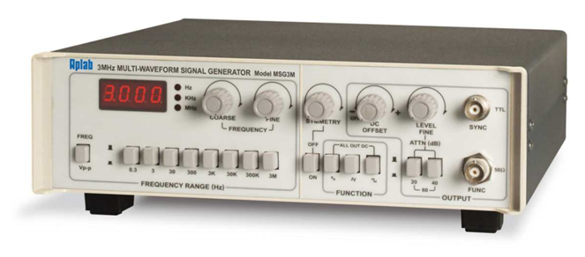

Post Lab Subjective/Objective type Questions:
- State the functions of C.R.O
Ans: The main function of the CRO is to apply the electrostatic energy on the electron ray from two vertical ways. The spot on the phosphor monitor turns due to the effect of these two electrostatic forces which are mutually perpendicular. It moves to make the necessary waveform of the input signal.
The CRO can therefore carry out many operations:
- Display the wave shapes.
- Measure voltage, current, frequency, time period, power and power factor.
- Compare two frequencies or waves.
- Study pulse width and pulse display
- Measure Phase difference.

- What is BJT? State the types of BJT
Ans: A bipolar junction transistor is a three-terminal semiconductor device that consists of two p-n junctions which are able to amplify or magnify a signal. It is a current controlled device. The three terminals of the BJT are the base, the collector, and the emitter. A signal of a small amplitude applied to the base is available in the amplified form at the collector of the transistor. This is the amplification provided by the BJT. Note that it does require an external source of DC power supply to carry out the amplification process.
There are two types of bipolar junction transistors:
PNP bipolar junction transistor
NPN bipolar junction transistor

Conclusion:
With the help of this experiment we are able to correctly understand the working principle of various components and Instruments and their applications’ in an electric circuit.

Signature of faculty in-charge with Date:

